JAVA ASSIGNMENT 22-09-2021

//Vigneshwar and Charran

package com.torryharris.mainpack;

import java.util.Scanner;

public class Main {

public static void main(String[] args) {

/*int coe=1,rows = 6;

for(int i = 0; i < rows; i++) {

for(int space = 1; space < rows - i; ++space) {

System.out.print(" ");

}

for(int j = 0; j <= i; j++) {

if (j == 0 || i == 0)

coe = 1;

else

coe = coe * (i - j + 1) / j;

System.out.printf("%4d", coe);

}

System.out.println();

}

------------------------------------------------------------------------------------------------------------------------------------------

Scanner sc = new Scanner(System.in);

System.out.println("Enter the two numbers ");

int n1 = sc.nextInt();

int n2 = sc.nextInt();

int gcd=1,lcm;

for (int i=1; i<=n1 && i<=n2; i++)

{

if( n1%i == 0 && n2%i == 0)

gcd = i;

}

lcm = (n1*n2)/n1;

System.out.println("gcd of "+n1+","+n2+" is "+gcd);

System.out.println("lcm of "+n1+","+n2+" is "+lcm);

int mark=40;

--------------------------------------------------------------------------------------------------------------------------------------

switch (mark/10){

case 10:

case 9:

System.out.println("A");

break;

case 8:

System.out.println("B");

break;

case 7:

System.out.println("C");

break;

case 6:

System.out.println("D");

break;

case 5:

System.out.println("E");

break;

case 4:

System.out.println("Fail");

break;

default:

System.out.println("invalid garde");

break;

}

---------------------------------------------------------------------------------------------------------------------------------------------

int n, remainder = 1, number, sum = 0;

Scanner sc = new Scanner(System.in);

System.out.print("Enter a number you want to check: ");

n = sc.nextInt();

number = n;

while (number > 9)

{

while (number > 0)

{

remainder = number % 10;

sum = sum + remainder;

number = number / 10;

}

number = sum;

sum = 0;

}

if (number == 1)

{

System.out.println("The given number is a magic number.");

}

else

{

System.out.println("The given number is not a magic number.");

}

}

}

------------------------------------------------------------------------

Done by:Sagar Deshmukh

5)

//to find palindrome number.

package com.torryharris;

import java.util.Scanner;

public class Main {

public static void main(String[] args) {

//checking for palindrome

Scanner sc = new Scanner(System.in);

System.out.println("enter the number");

int n = sc.nextInt();

int rem,rev=0;

int temp = n;

while(n>0)

{

rem = n % 10;

rev = rev * 10 + rem;

n = n/10;

}

n = temp;

if( n == rev)

{

System.out.println(n+" is a palindrome ");

}

else

System.out.println(n+" is not a palindrome");

}

}

output:

enter the number

1001

1001 is a palindrome

enter the number

1223

1223 is not a palindrome

--------------------------------------------------------------------------------

6)

//program to check whether entered number is Krishnamurthy number or not.(ex: 145=1!+4!+5!=145)

package com.torryharris;

import java.util.Scanner;

public class Main {

public static void main(String[] args) {

Scanner sc = new Scanner(System.in);

System.out.println(" enter the number ");

int num = sc.nextInt();

int fact=1,rem,sum=0;

int temp = num;

while(num!=0)

{

rem = num%10;

for (int i=1;i<=rem;i++)

{

fact = fact*i;

}

num = num/10;

sum = sum+fact;

fact = 1;

}

num = temp;

if(num == sum)

{

System.out.println(num+" is Krishnamurthy number ");

}

else

{

System.out.println(num+" is not a Krishnamurthy number ");

}

}

}

output:

enter the number

145

145 is Krishnamurthy number

enter the number

345

345 is not a Krishnamurthy number

------------------------------------------------------------------------------

7)

//program to find sum of even digits in a given number.

package com.torryharris;

import java.util.Scanner;

public class Main {

public static void main(String[] args) {

Scanner sc = new Scanner(System.in);

System.out.println(" enter the number");

int num = sc.nextInt();

int rem,sum=0;

int temp = num;

while( num != 0)

{

rem = num%10;

if(rem%2 == 0)

{

sum = sum+rem;

}

num = num/10;

}

num = temp;

System.out.println("sum of even digits in "+num+" is "+sum);

}

}

output:

enter the number

123456

sum of even digits in 123456 is 12

Process finished with exit code 0

---------------------------------------------------------------------------------

8)

//program to check whether the entered number is disarium number or not (ex:1)89=8^1+9^2=89 2)135=1^1+3^2+5^3 )

package com.torryharris;

import java.util.Scanner;

public class Main {

public static void main(String[] args) {

Scanner sc = new Scanner(System.in);

System.out.println("enter the number ");

int num = sc.nextInt();

int temp = num;

int rem,i=0,sum=0,rev=0,rem1;

while(num>0)

{

rem = num % 10;

rev = rev * 10 + rem;

num = num / 10;

}

while(rev>0)

{

rem1= rev%10;

i++;

sum = sum+(int)Math.pow(rem1,i);

rev = rev/10;

}

num = temp;

if(num == sum)

{

System.out.println(num+"is an disarium number ");

}

else

{

System.out.println(num+" is not an disarium number");

}

}

}

output1:

enter the number

89

89 is an disarium number

output2:

enter the number

154

154 is not an disarium number

Process finished with exit code 0

VENKATESH

Q9)) Fibonacci series :

package com.torryharris;

import java.util.Scanner;

public class Main {

public static void main(String[] args) {

Scanner sc = new Scanner(System.in);

int n1=0,n2=1,n3=0;

System.out.println("enter the number of elements to be printed: ");

int count = sc.nextInt();

System.out.println(n1);

System.out.println(n2);

for (int i=2;i<count;i++)

{

n3=n1+n2;

System.out.println(n3);

n1=n2;

n2=n3;

}

}

}

output :

enter the number of elements to be printed: 5

0

1

1

2

3

*********************************************************************************

Q10)) celsius to faherenheit conversion

package com.torryharris;

import java.util.Scanner;

public class Main {

public static void main(String[] args) {

Scanner sc = new Scanner(System.in);

System.out.println("enter the temperature in celsius");

double cel = sc.nextDouble();

double faher = (cel * 9/5)+32;

System.out.println("the temperature in Fahrenheit: "+faher);

}

}

output::

enter the temperature in celsius

32

the temperature in Fahrenheit: 89.6

*******************************************************************************

Q11) max element in array::

package com.torryharris;

import java.util.Scanner;

public class Main {

public static void main(String[] args) {

Scanner sc = new Scanner(System.in);

System.out.println("enter the number of elements in array");

int len = sc.nextInt();

int[] arr = new int[len];

System.out.println("enter "+len+" elements :");

for(int i =0;i<len;i++)

{

arr[i]=sc.nextInt();

}

int max=arr[0];

for(int i=1;i<arr.length;i++)

{

if (arr[i] > max)

max = arr[i];

}

System.out.println("the largest element in given array is : "+max);

}

}

output::

enter the number of elements in array

5

enter 5 elements :

45

78

98

56

32

the largest element in given array is : 98

*******************************************************************************************

Q12)) write a program to merge two sorted arrays

package com.torryharris;

import java.util.Arrays;

import java.util.Scanner;

public class Main {

public static void main(String[] args) {

Scanner sc = new Scanner(System.in);

System.out.println("enter the number of elements in array");

int len1 = sc.nextInt();

int[] arr1 = new int[len1];

System.out.println("enter "+len1+" elements :");

for(int i =0;i<len1;i++)

{

arr1[i]=sc.nextInt();

}

System.out.println("enter the number of elements in array");

int len2 = sc.nextInt();

int[] arr2 = new int[len2];

System.out.println("enter "+len2+" elements :");

for(int i =0;i<len2;i++)

{

arr2[i]=sc.nextInt();

}

int c =len1+len2;

int[] arr3 = new int[c];

for (int i=0;i<len1;i++)

{

arr3[i]=arr1[i];

}

for(int i=0;i<len2;i++)

{

arr3[i+len1]=arr2[i];

}

Arrays.sort(arr3);

for(int i=0;i<c;i++)

{

System.out.println(arr3[i]);

}

}

}

output::

enter the number of elements in array

3

enter 3 elements :

4

3

2

enter the number of elements in array

3

enter 3 elements :

1

8

9

1

2

3

4

8

9

**********************************************************

PAVAN KUMAR

13) public class Main {  
  
 public static void main(String[] args) {  
  
 int[] arr=new int[]{2,3,3,9,9,1,66,88,2,99,7};  
 int n= arr.length,count=0;  
 Arrays.sort(arr);  
 for(int j=0;j<n;j++){  
 for(int k=j+1;k<n;k++){  
 if(arr[j]==arr[k])  
 count++;  
 }  
  
 }  
  
 for(int i=0;i<n;i++) {  
 System.out.print(arr[i]+" ");  
 }  
 System.out.println();  
 System.out.println("No Of Repeated Integers = "+count);

}}

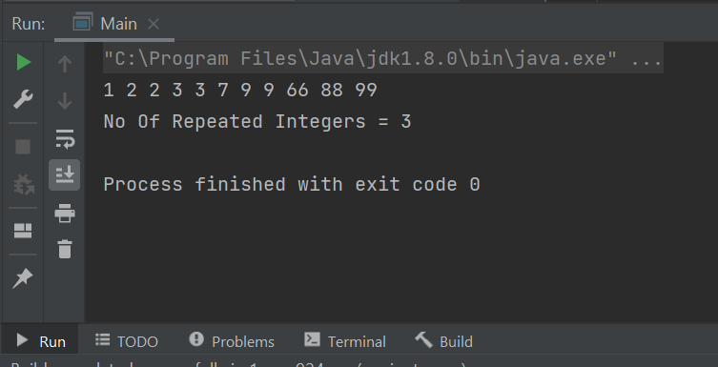

14) public static void main(String[] args) {

int i = 0, j, k;

int[] Dup_Count_arr = {10, 15, 25, 10, 8, 12, 10, 15, 55, 10, 60};

int Size = Dup_Count_arr.length - 1;

while(i < Size)

{

j = i + 1;

while(j < Size)

{

if(Dup_Count_arr[i] == Dup_Count_arr[j]) {

k = j;

while(k < Size) {

Dup_Count_arr[k] = Dup_Count_arr[k + 1];

k++;

}

Size--;

j--;

}

j++;

}

i++;

}

System.out.print("\nThe Final Array after Deleting Duplicates = " );

for(i = 0; i < Size; i++)

{

System.out.format("%d ", Dup_Count_arr[i]);

}

}

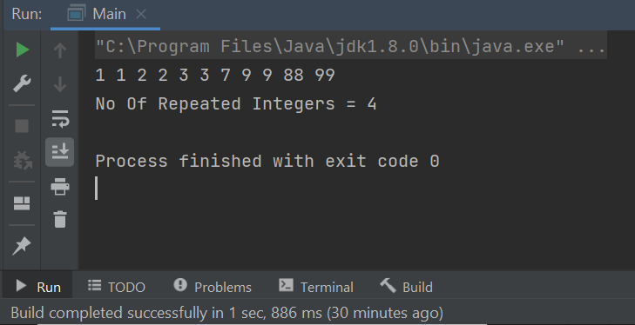

15)public class Main {  
  
 public static void main(String[] args) {

int[] arr=new int[]{10,20,30,40,50};  
 int n= arr.length;  
 Scanner sc=new Scanner(System.in);  
 System.out.println("Enter the element and Position to replace");

int Ele=sc.nextInt();  
 int Pos= sc.nextInt();  
  
 for(int i=0;i<n;i++){  
 if(i+1==Pos){  
 arr[i]=Ele;  
 }  
 }  
 for (int i = 0; i < n; i++)  
 System.out.print(arr[i]+" ");

}

}

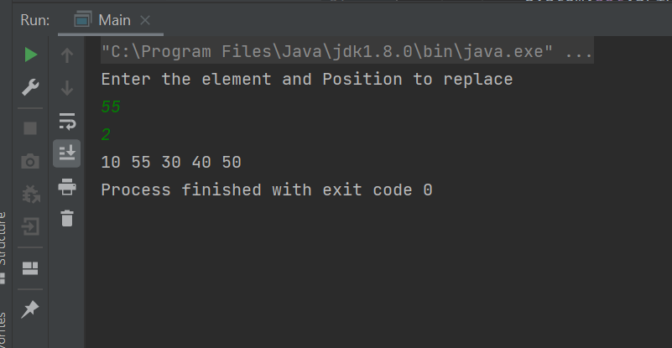

16)

public class Main {  
  
 public static void main(String[] args) {

Scanner sc=new Scanner(System.*in*);  
 int number, temp, total = 0;  
 System.*out*.println("Enter the Number");  
 int num=sc.nextInt();  
 number = num;  
 while (number != 0)  
 {  
 temp = number % 10;  
 total = total + temp*temp*temp;  
 number /= 10;  
 }  
  
 if(total == num)  
 System.*out*.println(num + " is an Armstrong number");  
 else  
 System.*out*.println(num + " is not an Armstrong number");  
  
  
 }  
  
  
  
  
}

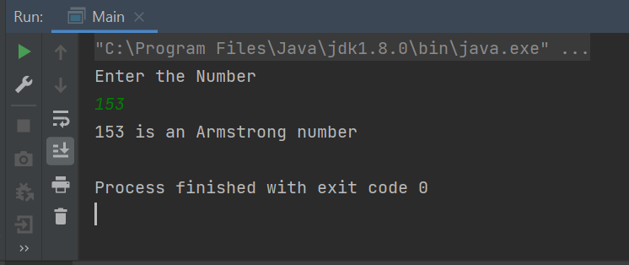

**(Done by R.Priyadharshini)**

17.**In mathematics, a number is called an Automorphic number if the square of the number ends with the same number.** Example of [Automorphic numbers](https://en.wikipedia.org/wiki/Automorphic_number) are:- **5, 6, 25, 76, e.t.c..**

**Program:**

**package** com.torryharris;  
import java.util.Scanner;  
public class Main {  
 public static void main(String[] args) {  
 Scanner sc = new Scanner(System.*in*);  
 System.*out*.println("Enter a number");  
 int num= sc.nextInt();  
 int temp=num;  
 int square=num*num,c=0;  
 while(temp>0)  
 {  
 c++;  
 temp=temp/10;  
 //System.out.println(square);  
 }  
 int last=(int)(square%(Math.*pow*(10,c)));  
 if (num==last)  
 System.*out*.println(num+" is a Automorphic number");  
 else  
 System.*out*.println(num+" is not a Automorphic number");  
 }  
}

**Output:**

**Enter a number**

**5**

**5 is a Automorphic number**

**18.we will develop a Java program for a BMI calculator.**

**The BMI stands for Body Mass Index. It is a measure of health based on height and weight. It can be calculated by taking the weight in kilograms and dividing it by the square of your height in meters.**

**Formula for Calculating BMI in Metric Units,**

**BMI = (Weight in Kg) / (Height in Meters * Height in Meters)**

**For example,  
weight = 75 kg, height = 1.5 m  
BMI = 75 / (1.5*1.5) = 33.33**

**Using the range of BMI, individuals are classified as underweight, normal or overweight. Its value is in a specific range for a healthy individual. The following table shows the main BMI categories,**

|  |  |
| --- | --- |
| ***BMI Range*** | ***Category*** |
| **< 18.5** | **Thinness** |
| **18.5 – 25** | **Normal** |
| **25 – 30** | **Overweight** |
| **> 30** | **Obese** |

[**BMI calculator**](https://calculator-online.net/bmi-calculator/)**finds whether the person is underweight, normal, overweight, or obese. The person who wants to lose their want can use a**[**weight loss calculator**](https://www.calculators.org/health/weight-loss.php)**which can tell the daily caloric requirements, and many easy tips to lose weight.**

**Program:**

package com.torryharris;  
import java.util.Scanner;  
public class Main {  
 public static void main(String[] args) {  
 Scanner sc =new Scanner(System.*in*);  
 System.*out*.println("Enter your weight in kg");  
 double weight_kg = sc.nextDouble();  
 System.*out*.println("Enter your height in kg");  
 double height_m = sc.nextDouble();  
 double BMI= (weight_kg/(height_m*height_m));  
 if (BMI<18.5)  
 {  
 System.*out*.println("Under weight");  
 }  
 else if (BMI<25)  
 {  
 System.*out*.println("Normal");  
 }  
 else if (BMI<30)  
 {  
 System.*out*.println("Overwight");  
 }  
 else  
 {  
 System.*out*.println("obese");  
 }  
 }  
}

**output:**

Enter your weight in kg

55

Enter your height in kg

1.5

Normal

**19.Perfect number**:- **A number whose factors sum except itself, is equal to the same number is called a**[**perfect number**](https://en.wikipedia.org/wiki/Perfect_number)**.**

**Program:**

**package** com.torryharris;  
import java.util.Scanner;  
public class Main {  
 public static void main(String[] args) {  
 Scanner sc =new Scanner(System.*in*);  
 System.*out*.print("Enter the number:");  
 int n=sc.nextInt();  
 int sum=0;  
 for (int i=1;i<=(n/2);i++)  
 {  
 if(n%i==0)  
 {  
 sum= sum+i;  
 System.*out*.println(sum);  
 }  
 }  
 if (sum== n)  
 {  
 System.*out*.println(n+" is a perfect number");  
 }  
 else  
 {  
 System.*out*.println(n+" is not a perfect number");  
 }  
 }  
}

**Output:**

**Enter the number:496**

**1**

**3**

**7**

**15**

**31**

**62**

**124**

**248**

**496**

**496 is a perfect number**

**20.Write a Java program to find the second largest number in Java.**

**Program:**

package com.torryharris;  
public class Main {  
 public static void main(String[] args) {  
 int[] arr ={70,100,150,99,50,98};  
 for (int i=0;i<arr.length;i++)  
 {  
 for (int j=i+1;j<arr.length;j++){  
 if (arr[i] < arr[j]){  
 int temp = arr[i];  
 arr[i] = arr[j];  
 arr[j]=temp;  
 }  
 }  
 }  
 System.*out*.println((arr[1])+" is the second largest number.");  
 }  
}

**Output:**

100 is the second largest number.

